Project Design Phase-II Technology Architecture

|  |  |
| --- | --- |
| Date | 22 October 2022 |
| Team ID | PNT2022TMID08105 |
| Project Name | Analytics for Hospital’s Health-Care Data |
| Maximum Marks | 4 Marks |

Technical Architecture:

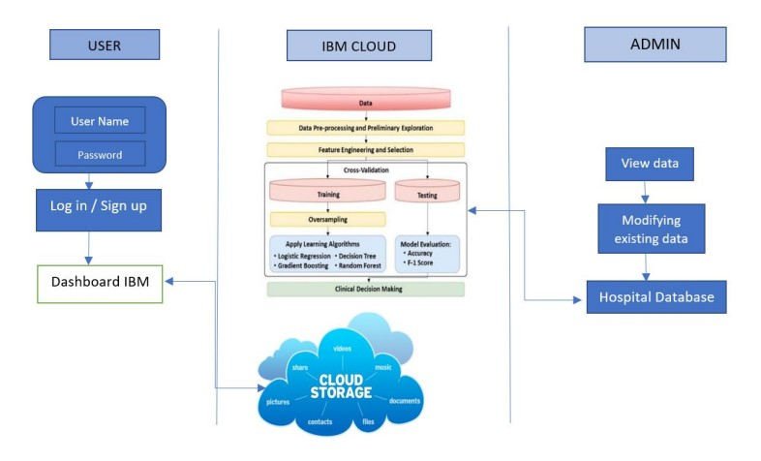

Table-1 : Components & Technologies:

|  |  |  |  |
| --- | --- | --- | --- |
| S.N o | Component | Description | Technology |
| 1. | User Interface | The User can interact through the site with their convenient communicative device | HTML, CSS, JavaScript / Angular  Js / React Js etc… |
| 2. | Application Logic-1 | Collecting the data | CSV File |
| 3. | Application Logic-2 | Exploring and Visualizing the data | IBM Cognos Analytics |
| 5. | Database | Data model on the available data | AI or ML |
| 6. | Cloud Database | Storing the Patients data in an cloud environment | IBM Cloud |
| 7. | External API-1 | Purpose of External API used in the application | Aadhar API, etc.. |
| 8. | Machine Learning Model | Predictive analysis on the data model | Regression Model |
| 9. | Infrastructure (Server / Cloud) | Cloud environment for analytics | Local, Cloud Foundry, Kubernetes, etc. |

Table-2: Application Characteristics:

|  |  |  |  |
| --- | --- | --- | --- |
| S.No | Characteristics | Description | Technology |
| 1. | Open-Source Frameworks | List the open-source frameworks used | Python |
| 2. | Security Implementations | Admin and User Authorization or Management Authorization | Encryption,IAM  Controls,OWASP,etc... |
| 3. | Availability | The data exploring and visualizing is a timely work hence the system should be more available | Cognos Analytics |
| 4. | Performance | The accurate calculation of data is the well-known performance of the system | Predicting analysis using specific ideas |